6.2 APQB – Exchange Rates
- If the price of the Swedish krona changes from 12 Japanese yen per krona to 13 Japanese yen per krona, then which of the following describes the change in the yen and the change in the cost of Swedish goods to residents of Japan?
 | Yen | Change in cost of Swedish goods to residents of Japan
A | Depreciation | Increase
B | Depreciation | Decrease
C | Depreciation | No change
D | Appreciation | Increase
E | Appreciation | Decrease

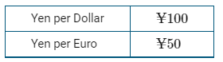
- The table below gives the number of Japanese yen needed to buy a United States dollar ($) and the number of Japanese yen needed to buy a euro (€).
Given the currency values, which of the following must be true?
- Goods are cheaper in Eurocurrency nations than in the United States.
- It takes more dollars than euros to buy the yen.
- One euro is worth $0.50.
- One yen is worth $100.
- The yen has depreciated.
- The price of a Japanese-made pen in Japan is ¥500. If at the current exchange rate a German buyer can buy the pen in Japan for €100, then which of the following is the exchange rate between the two currencies?
- 5 Euros / Yen
- 500 Euros / Yen
- 0.2 Yen / Euro
- 5 Yen / Euro
- 20 Yen / Euro
- In the foreign exchange market, the exchange rate is defined as
- the price of one currency in terms of another currency
- the price of goods around the world
- the price of a good in terms of another good
- the discount that companies take when goods are returned
- the quantity of a good to be traded for a unit of another good
- Which of the following is most likely to benefit from an appreciation in the United States dollar in the short run?
- United States investors holding European bonds
- Importers in foreign countries seeking raw inputs at a lower price
- United States exporters selling capital equipment
- United States tourists traveling to foreign countries
- European consumers buying United States goods
- The price of one nation’s currency expressed in terms of another nation’s currency is called
- the world price
- the exchange rate
- the law of one price
- terms of trade
- purchasing-power parity
- The exchange rate is 1.2 euros per United States dollar. If a restaurant meal costs 30 euros in Paris, France, what is its dollar cost to a United States tourist?
- $2.50
- $3.60
- $25
- $30
- $36

Free Response
- Singapore and Japan are trading partners. The Japanese economy is operating at full employment, and Japan’s current account balance is zero.
- Assume the exchange rate between the Singapore dollar (SGD) and the Japanese yen (JPY) changes from 1 SGD = 82 JPY to 1 SGD = 65 JPY. Does the JPY appreciate or depreciate against the SGD?
- Given your answer in part (a), will each of the following increase, decrease, or remain the same?
- The price of Japanese goods in Singapore dollars
- Japan’s net exports
- Draw a single correctly labeled graph with the long-run Phillips curve and short-run Phillips curve for Japan. On the graph, show the new short-run equilibrium as a result of the change in Japan’s net exports from part (b)(ii), labeled point X.
- Given your answer in part (b)(ii), will each of the following be in deficit, surplus, or zero for Japan?
- Current account balance
- Financial (capital) account balance

Answer
1. A 2. C 3. D 4. A 5. D 6. B 7. C
Free Response
1
A 1 point is earned for: stating that JPY appreciates relative to the SGD.
B 1 point is earned for: stating that the price of Japanese goods in Singapore dollars will increase.
1 point is earned for: stating that Japan’s net exports will decrease.

C 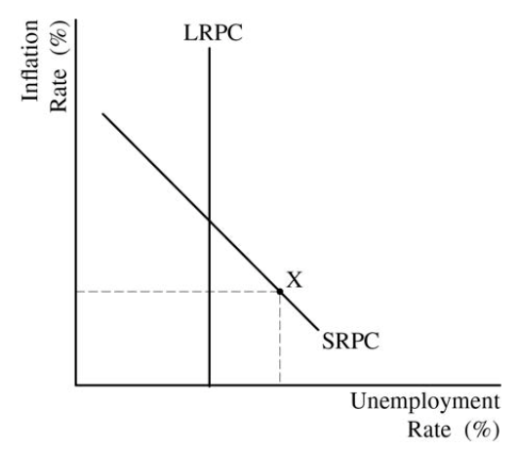
D 1 point is earned for: stating that Japan’s current account balance will be in deficit and that Japan’s financial (capital) account balance will be in surplus.

